H.K.PEIRIS

IT13116002

4th Year

Lab - 02

AWS Linux

ESBPII

Amazon EC2 Linux Instances

1. Creating an instance
2. 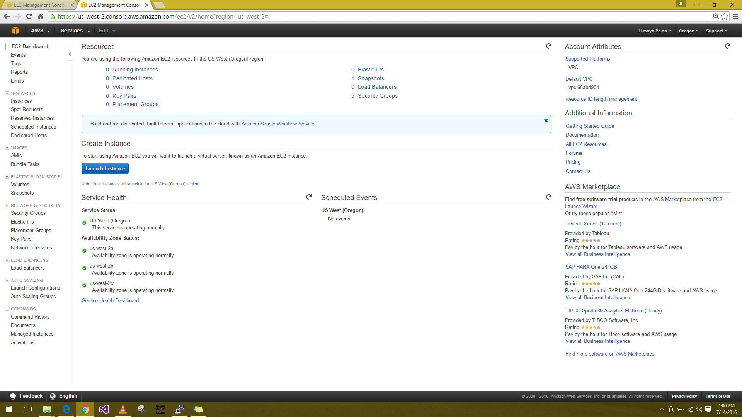EC2 Console dashboard 🡪 Launch Instance
3. 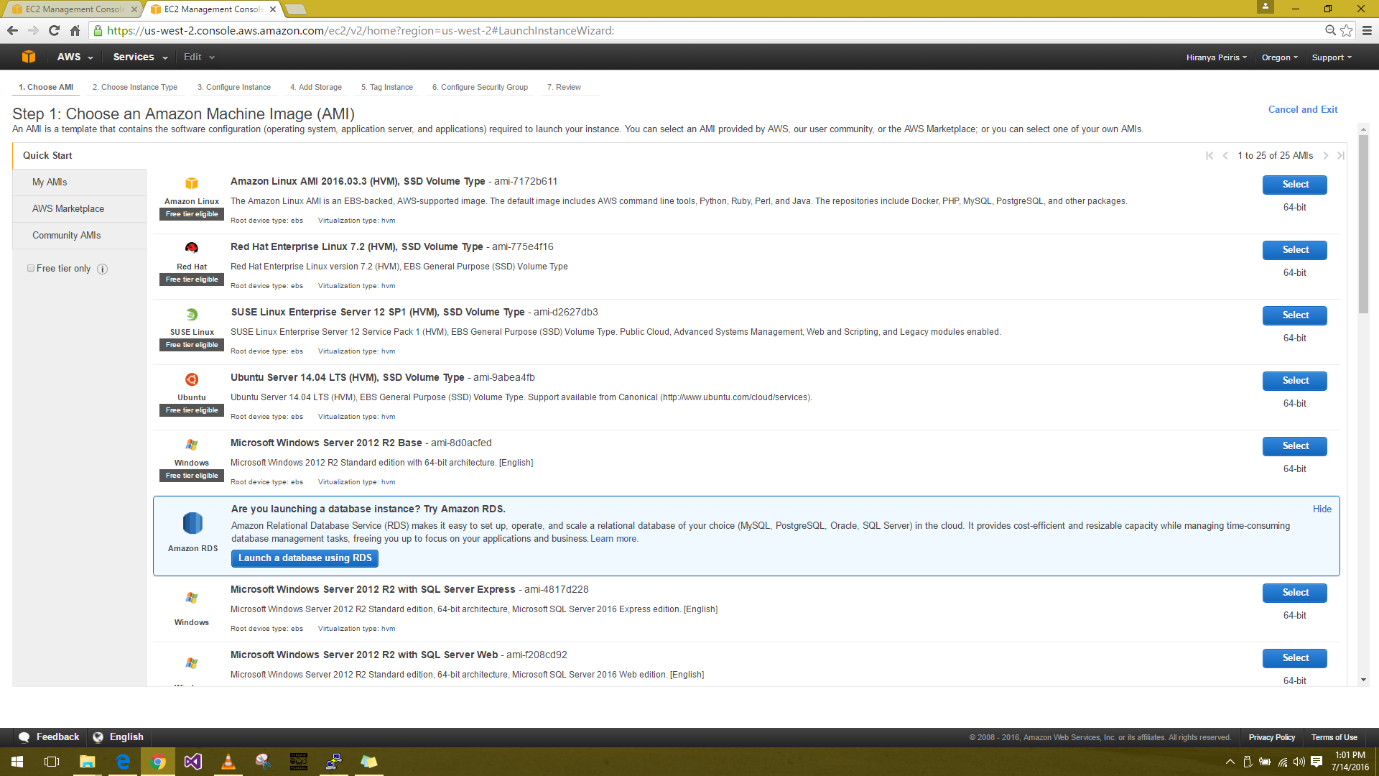Selecting an Amazon Machine Image (AMI) 🡪 Amazon Linux AMI (**Free tier eligible**)
4. 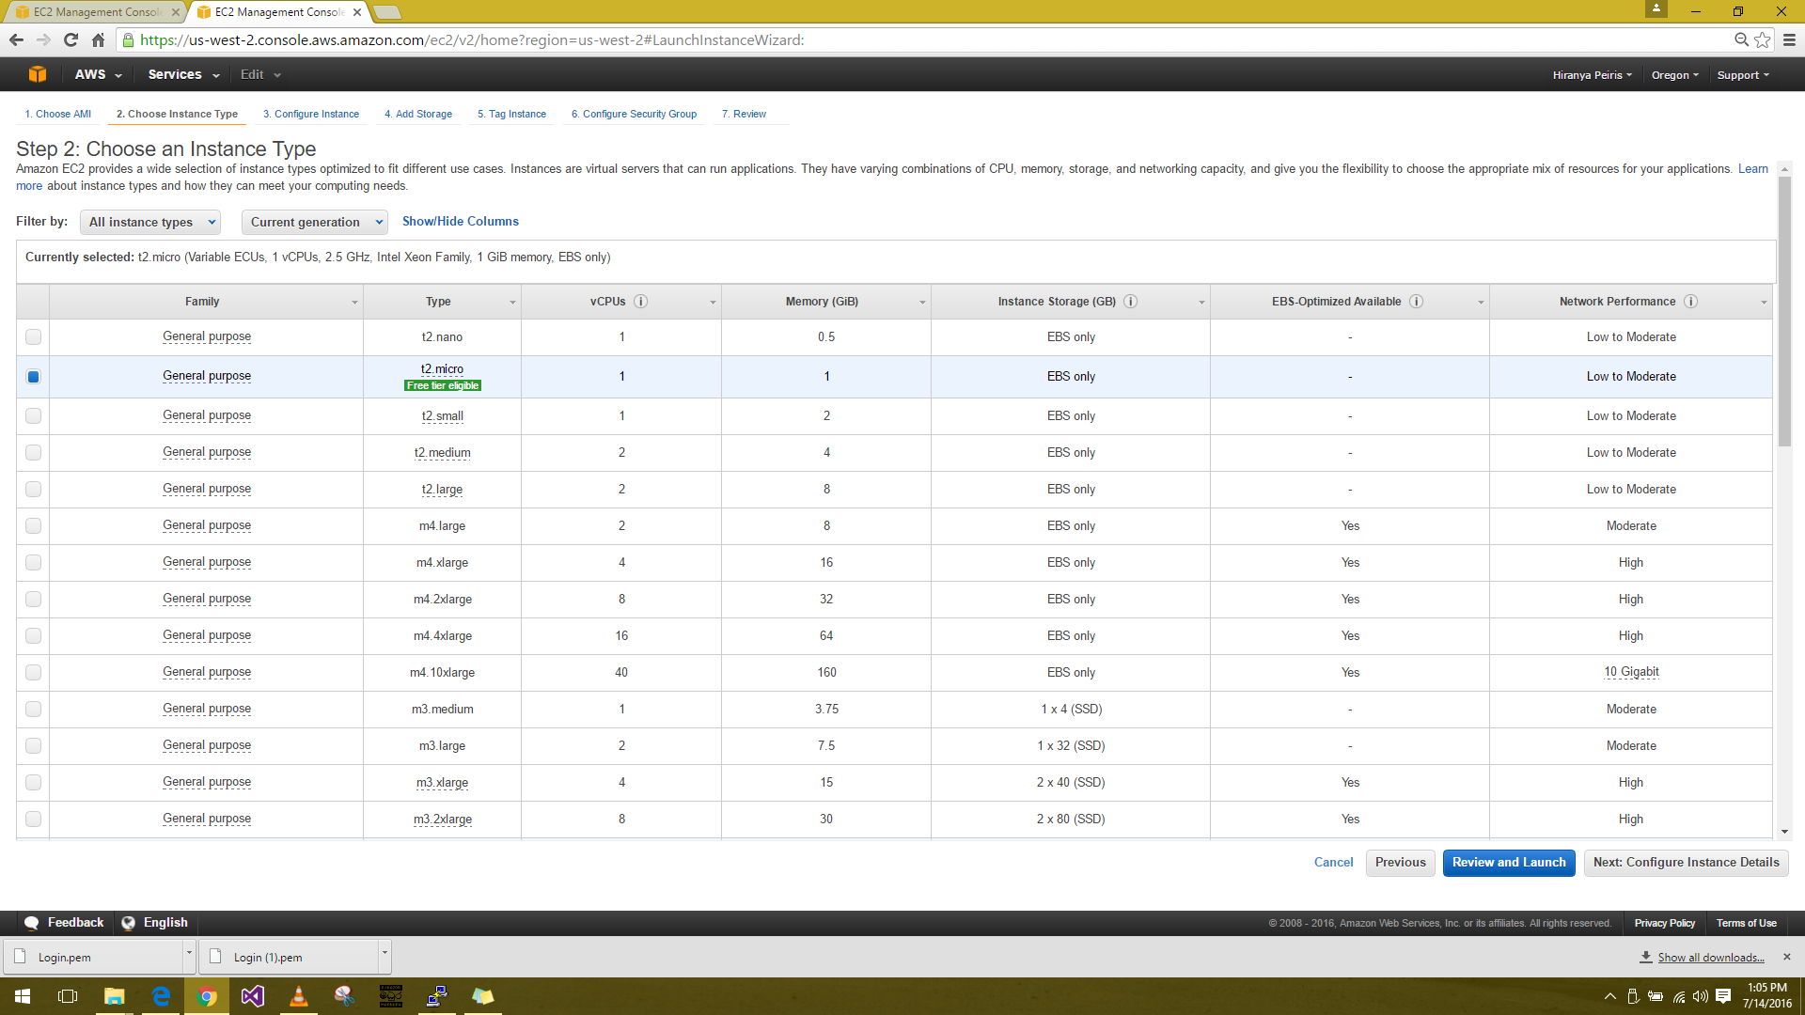Choosing an instance type page 🡪 t2.micro - Default (**Free tier eligible**)
5. 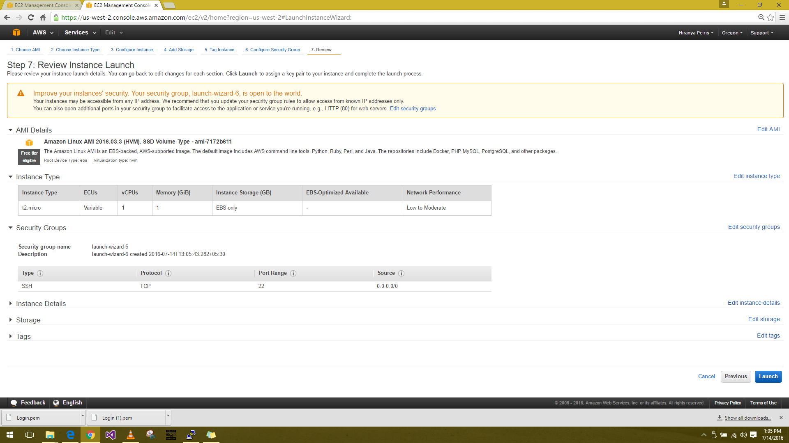Review instance launch 🡪 Launch
6. 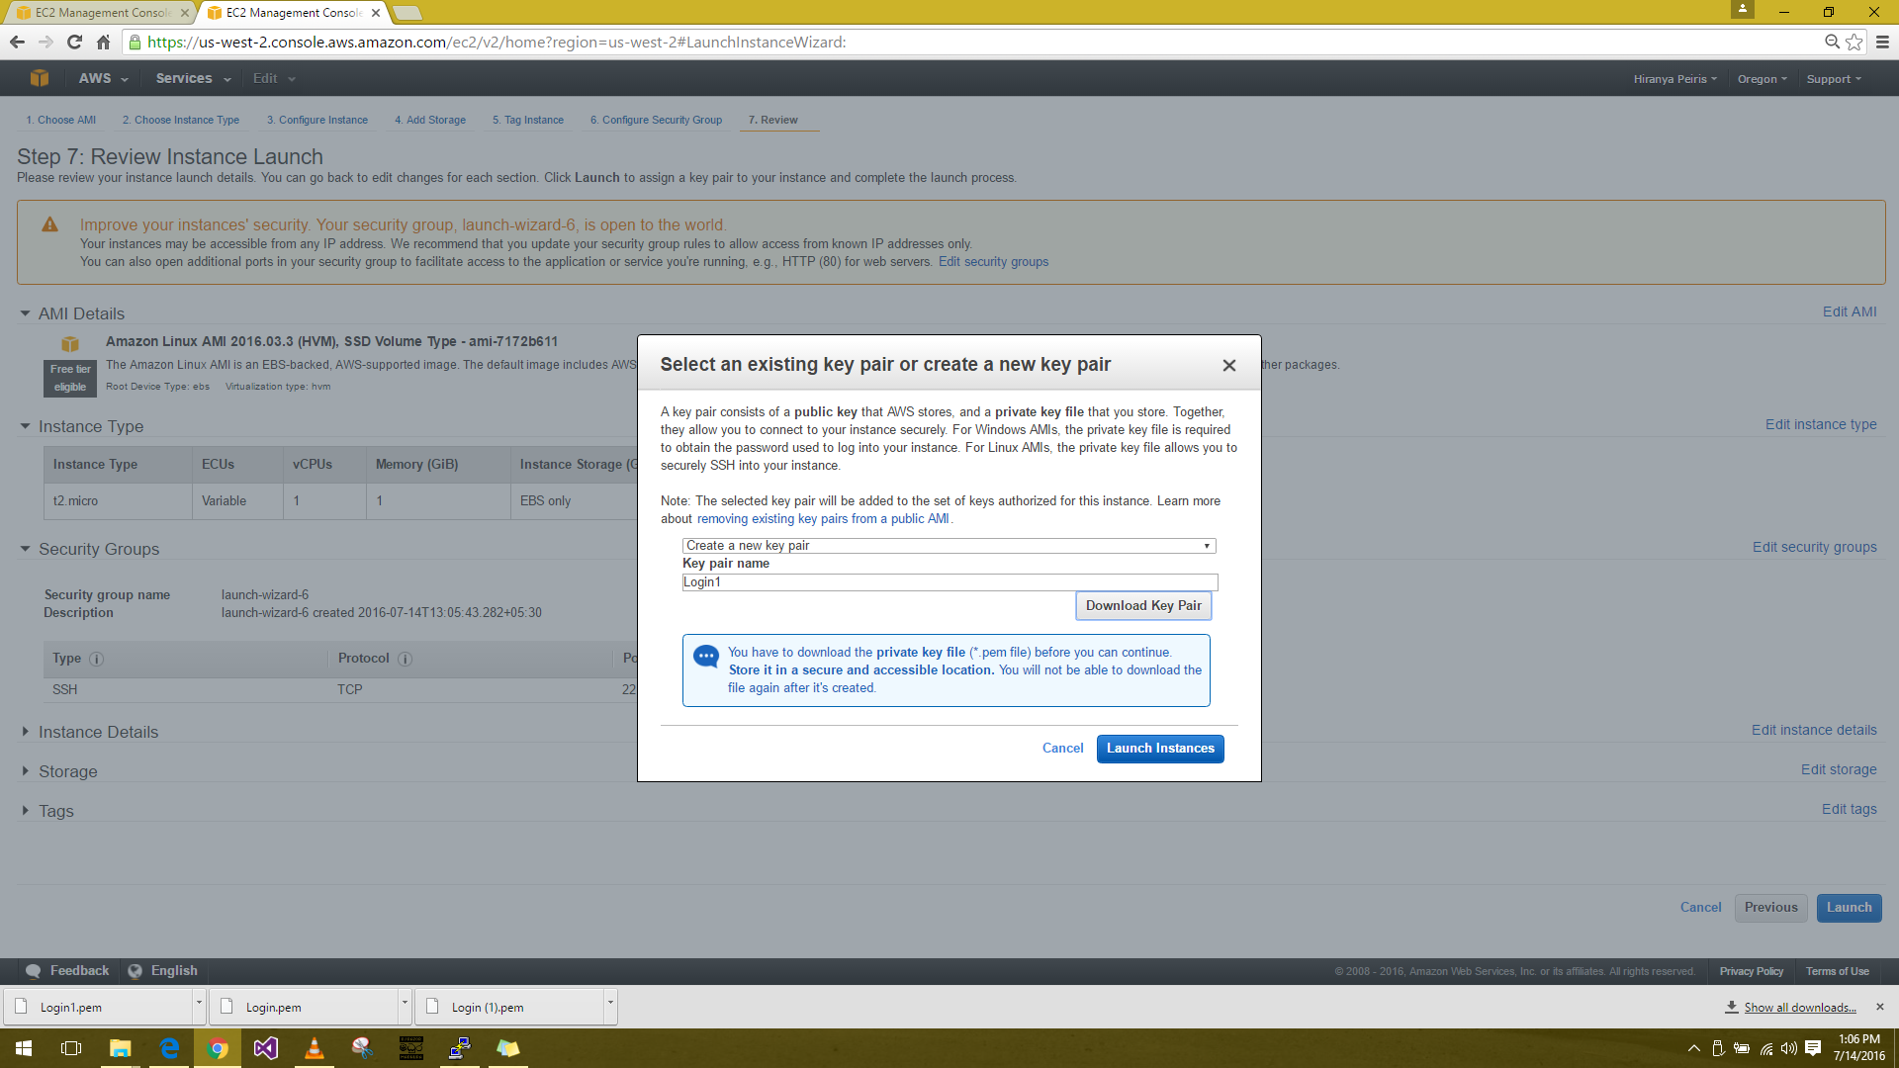Create a new key pair 🡪 Download Key Pair
7. Launching Instance

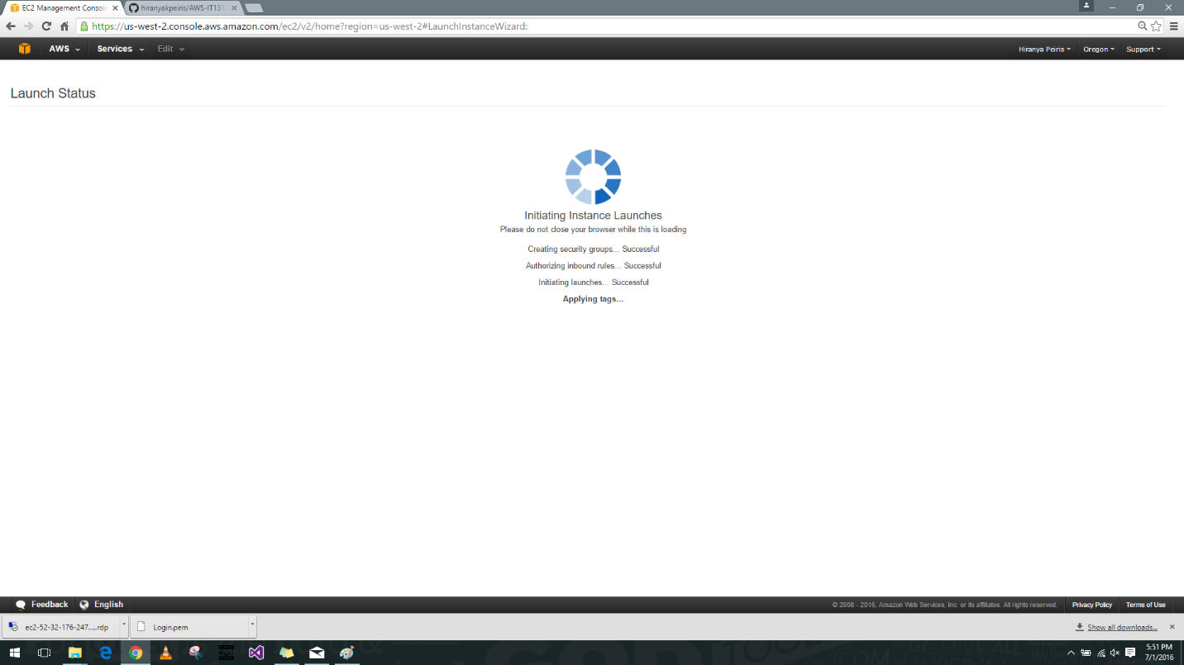

1. 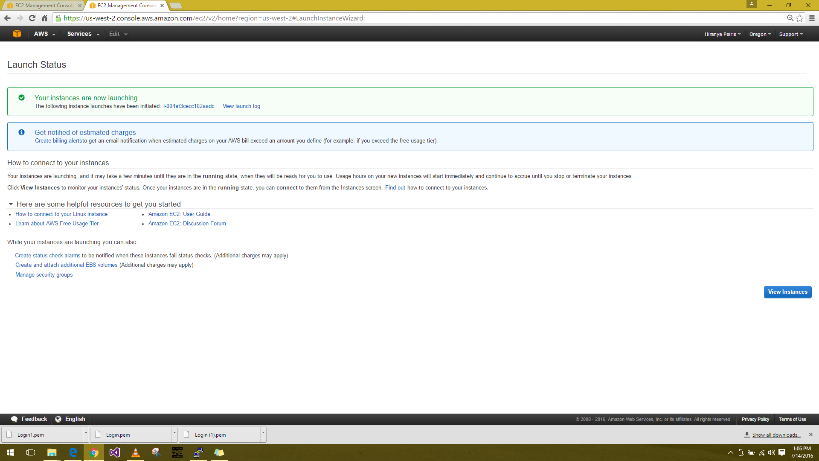Launch Status
2. Instance is up and running

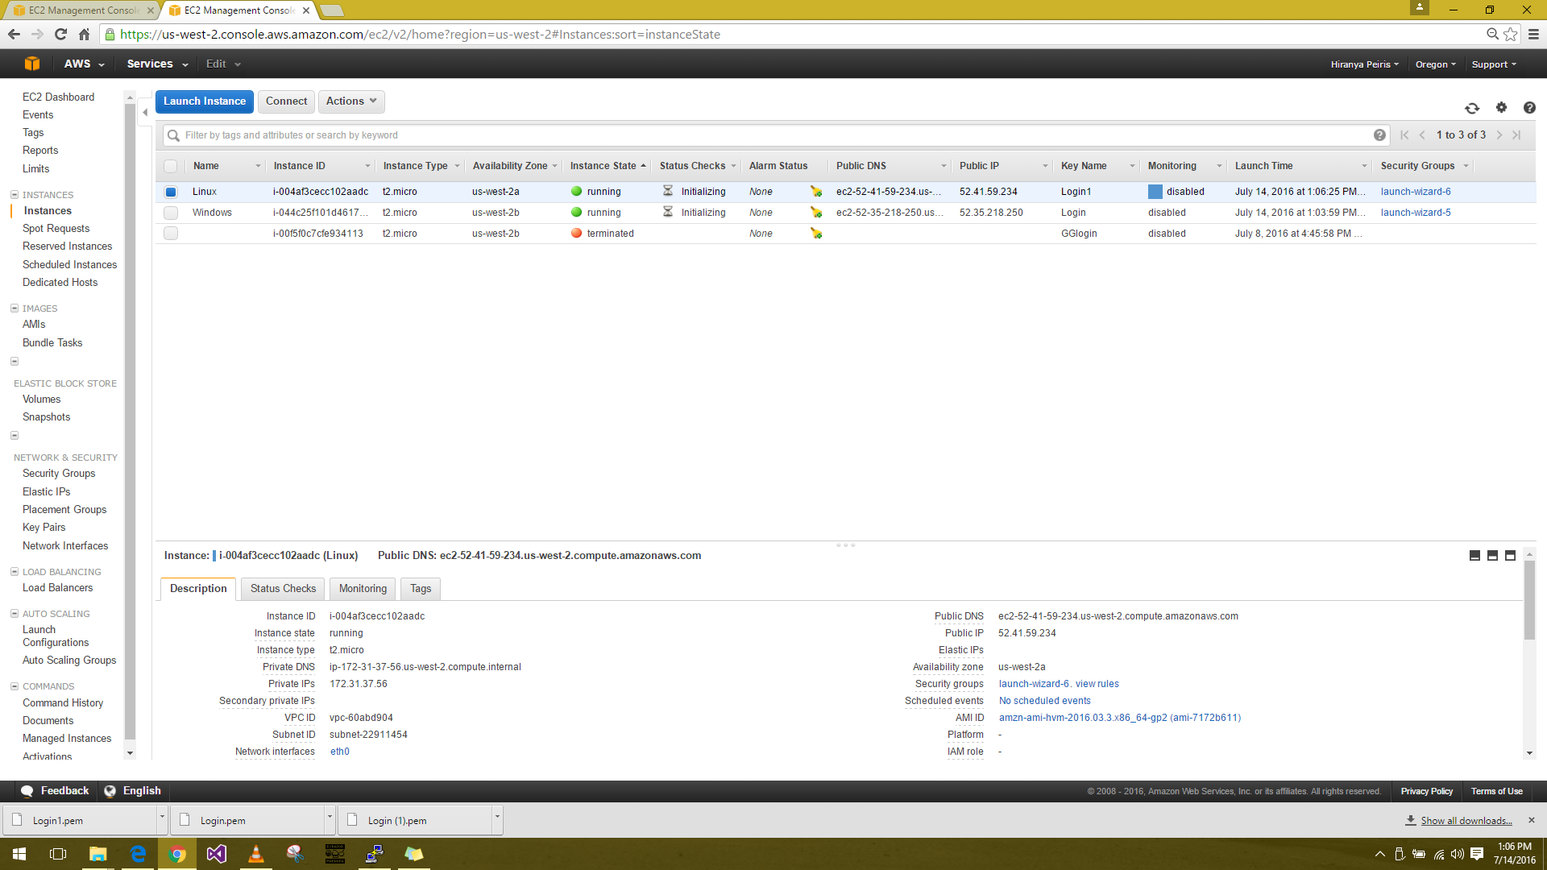

1. Connect to the instance
2. 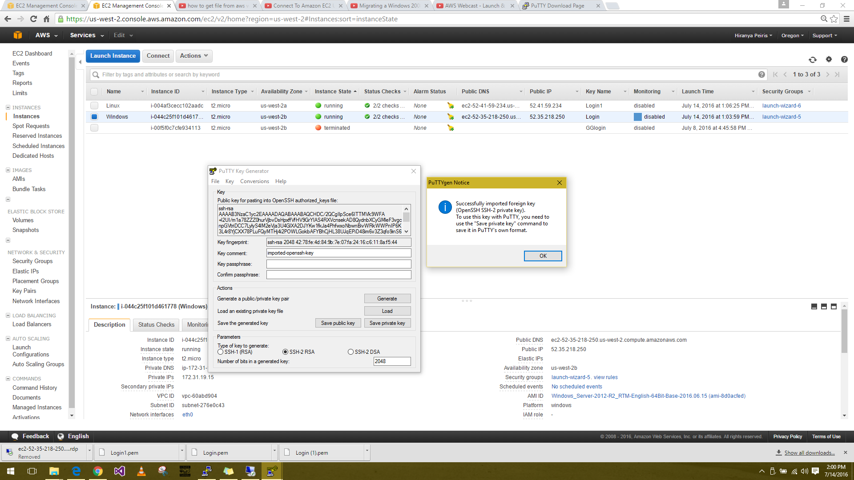Converting key pair (.pem) into private key (.ppk) by Putty Key Generator
3. 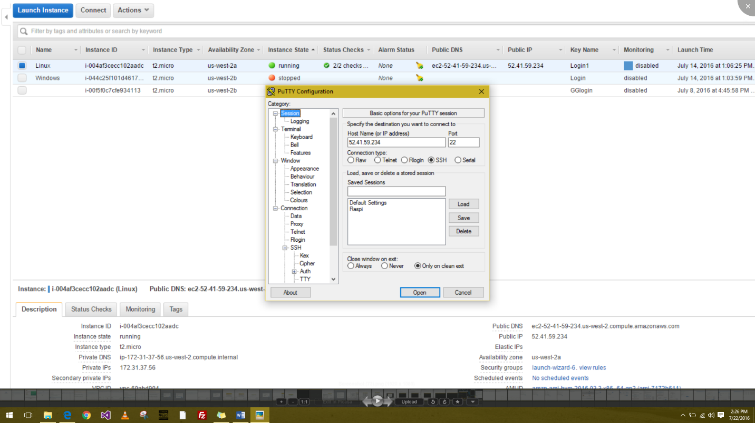Connect through Putty using public IP by key pair (.ppk)

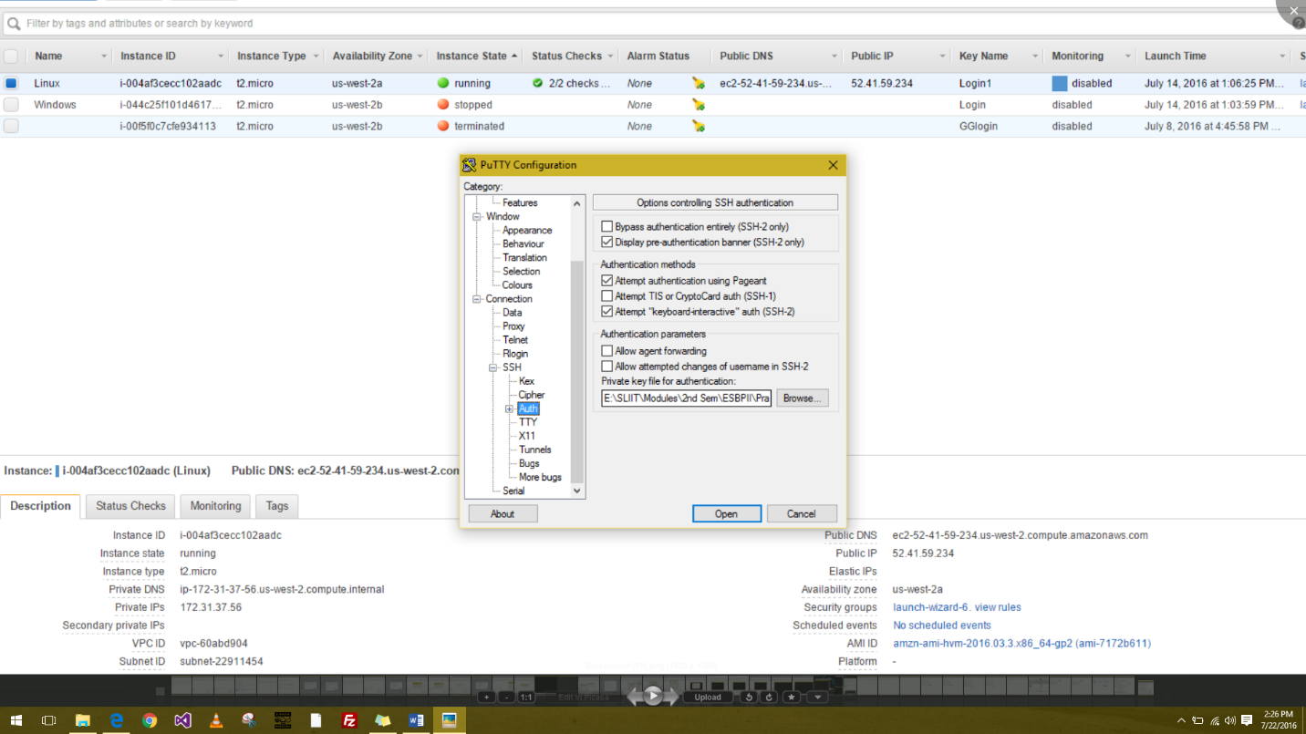

1. 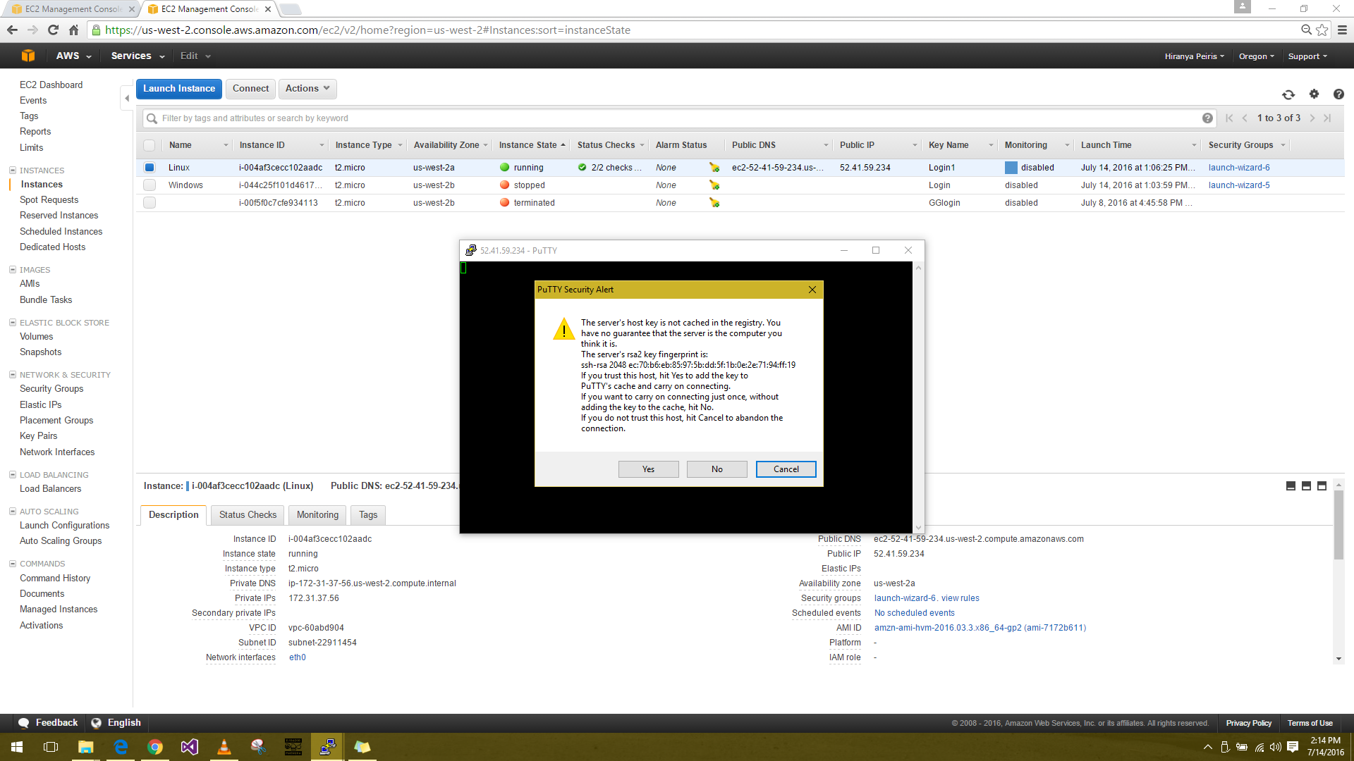Launch SSH Client
2. User name = ec2-user 🡪 Connected to instance

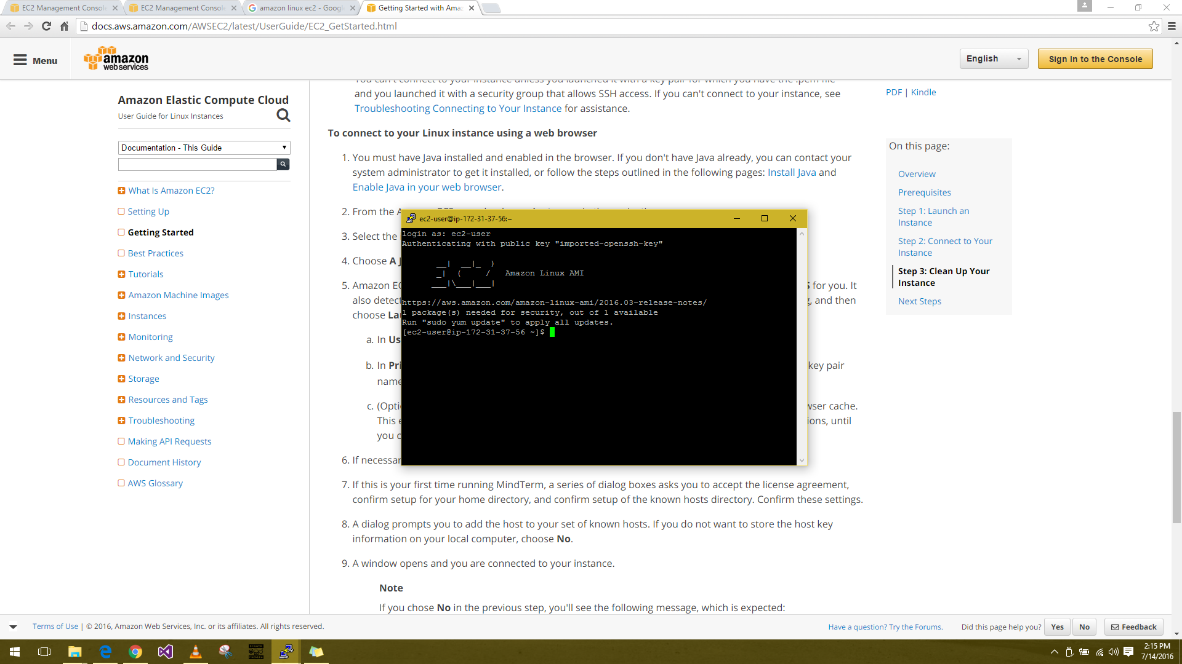

1. Trying an exercise
2. 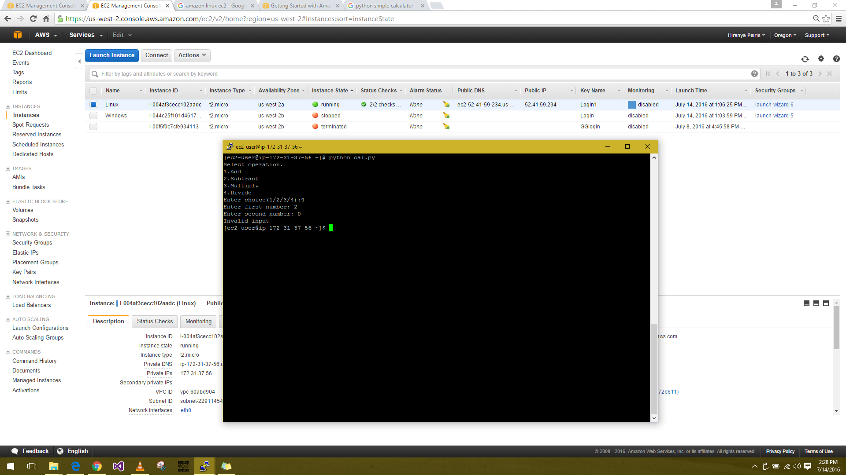Calculator